Project 2

Assessing Potential Vulnerabilities by Analyzing Source Code of Networking Systems

Objective
To analyze an existing code base for potential vulnerabilities.

Description
- Students may work individually or form a team of up to four members to complete the project. While teamwork is allowed, students are encouraged to complete the project on their own.
- All students must submit their own answers to this project.
- Both undergraduate and graduate students are required to answer all questions.
Submission
- All students must complete Project 2, which is listed under the Quiz category;
- All students must also submit an analysis report (using this template) explaining how the results were derived from the given trace. Students working in the same team may submit an identical report; however, each student must upload the report individually.
- For your answer to each question in the analysis report, please include the screenshot of the relevant code snippet and your analysis.

Two Networking Systems - A DNS Relay and An Embedded System
1. The DNS Relay
Included with this project is a copy of the source code of a Java project called DenisDNS. DenisDNS is an open-source DNS relay that while capable of basic functionality has crucial security vulnerabilities. You will need to download the source from CEG6430/DenisDNS at main · jzhang369/CEG6430 (github.com)
This is a relatively small codebase so it should be highly accessible to you to perform code auditing. Nevertheless, if you want to expedite your analysis, you might want to prioritize your analysis for the following classes/methods.
- DnsServer.java: run(): The main execution loop of the program.
- DnsResolver.java: addressForHost(): The method where DennisDNS queries another DNS server when it cannot find the IP address it is trying to resolve in its own cache.
- DnsResponse.java: The class in which a response from the DNS server queried is parsed by the program for use, starting with the constructor.
For this project, you will NOT need to run DenisDNS. However, if you want to run this relay, observe its run time behaviors, the following information might be of help.
- A Java Runtime at version 7 or higher is required to run DenisDNS.
- A pre-compiled copy of DenisDNS is included as "DenisDNS.jar". Run it from the command line with "java -jar DenisDNS.jar".
- In order to test the server, the dig unix command (nslookup is an equivelent tool that can be used on Windows) can be used on the same computer with the command "dig @127.0.0.1 -p port domain" where port is the port number listed by DenisDNS when it is executed and domain is the domain name you wish to look up.
2. The Embedded System
Included with this project is a copy of the source code of a real-time operating system, which is modified from FreeRTOS, an open-source market-leading real-time operating system (or RTOS). We deliberately add some security flaws into the source code. You need to analyze this program and answer questions relevant to vulnerabilities. You can access the source code from CEG6430/EmbeddedSystem/160919_FreeRTOS_Labs - Broken at main · jzhang369/CEG6430 (github.com)
Since the codebase of this system is relatively large, we offer a list of files that are relevant to this project, hoping to expedite your analysis if needed.
- 160919_FreeRTOS_Labs-Broken/FreeRTOS-Plus/Source/FreeRTOS-Plus-TCP/FreeRTOS_TCP_WIN.c : This file implements the TCP window and congestion control.
- 160919_FreeRTOS_Labs-Broken/FreeRTOS-Plus/Source/FreeRTOS-Plus-TCP/FreeRTOS_TCP_IP.c: This file implements the TCP-IP protocol.
- 160919_FreeRTOS_Labs-Broken/FreeRTOS-Plus/Source/FreeRTOS-Plus-TCP/FreeRTOS_Sockets.c : Implement how the socket is initialized.
- 160919_FreeRTOS_Labs-Broken/FreeRTOS-Plus/Demo/FreeRTOS_Plus_TCP_Minimal_Windows_Simulator/main.c : The main file of FreeRTOS windows simulator.
- 160919_FreeRTOS_Labs-Broken/FreeRTOS-Plus/Demo/FreeRTOS_Plus_TCP_Minimal_Windows_Simulator/FreeRTOSConfig.h : Configuration file of FreeRTOS windows simulator application.

Your Name: Josiah Schmitz

UID: U01049737

Q1. The DenisDNS relay properly verifies whether the source IP address of the received DNS response is the same as the IP address of the DNS server to which the DNS query is sent.
True/False?
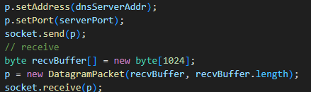
Answer: False. There is no verification step in this code which both sends and receives a datagram packet through the resolver. There should be code which checks if p’s address is the same as ‘dnsServerAddr’. This could be something like ‘p.getAddress().equals(dnsServerAddr)’.

Q2. The DenisDNS relay properly verifies whether the transaction ID of the received DNS response is the same as the transaction ID of the DNS query.
True/False?
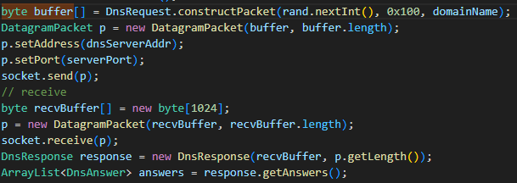
Answer: False. Similarly to the last question, there is no code that provides a check for where the query and response have the same transaction ID. The initial transaction ID is generated when ‘constructPacket()’ is called, but there is no check for a matching ID after the response is received. A check that could solve the issue might be ‘this.getTxnID().equals(txnID)’.

Q3. The DenisDNS relay properly verifies whether the domain name contained in the received DNS response is the same as the domain name of the DNS query.
True/False?
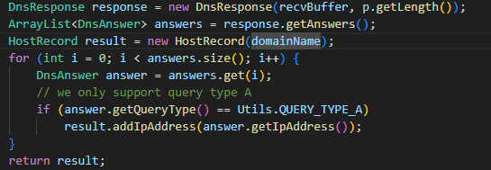
Answer: False. Once again, there is no check in the code to make sure the domain names in the response and query match. In the code snippet, a response is created and answers are added from that response without any verification of the accuracy of the domain name. This creates a vulnerability to DNS spoofing attacks.

Q4. The DenisDNS relay will cache a DNS response
[] for 360 seconds or 6 minutes.
[] for 60 seconds or 1 minute.
[] for 180 seconds or 3 minutes.
[] indefinitely (i.e. forever) as long as the DenisDNS process is active.
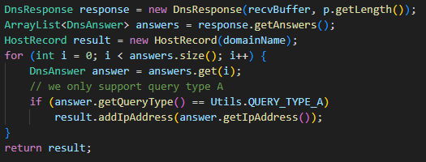
Answer: Indefinitely. While the first code snippet (from DnsResponse.java) does initialize a 6-minute TTL, it is never implemented. Looking at the second code snippet (from DnsResolver.java), answers are extracted and their IP’s are added to the host record. However, nowhere in this sequence is the TTL ever extracted from the DNS response and actually implemented to limit the time the response is cached. This means that the responses will be cached indefinitely, until the main process shuts down.

Q5. The DenisDNS relay is vulnerable to DNS cache positioning attacks where a forged DNS response can be received, accepted, processed, and cached by this DenisDNS relay.
True/False
Answer: True. Looking at the code snippets provided in the previous answers, we can see that there is no validation for the correct IP address, transaction ID, or domain name when the program adds answers from DNS responses. This lack of authentication, combined with indefinite caching of DNS responses, means that attackers can pretty easily use DNS cache poisoning to generate a forged DNS response that will be cached by the program and potentially used to redirect a device to an incorrect IP address.

Q6. The random numbers generated by this TCP/IP stack implementation are predictable.
True/False
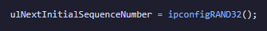
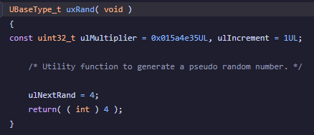
Answer: True. In the first code snippet above (from FreeRTOS_Sockets.c), we see that the sequence numbers generated for this TCP program are randomized using ‘ipconfigRAND32()’. This function is implemented by calling ‘uxRand()’ (see second code snippet from FreeRTOSIPConfig.h), which is written in the third code snippet (from main.c). Here we see that uxRand() is not actually generating random numbers at all and is only returning 4 every time it is called.

Q7. The initial value of the sequence number for a new TCP connection, when it is generated by this embedded system, is predictable.
True/False
Answer: True. In the screenshots and answer for the previous problem, we see that the random numbers being generated by this program are not random at all. Because of this, the starting sequence number for the TCP program will always be the same number (specifically 4) and, consequently, can always be predicted. This can very easily lead to TCP spoofing or session hijacking attacks if not fixed.

